**Student Information**

* **Name:- Aditya Kumar**
* **Sap Id :- 590015145**
* **Branch :- M.C.A**
* **Batch :- B1**
* **Instructor :-Dr. Sourbh Kumar**

**Lab Assignment 1: Stack Implementation Using Arrays**

**#include <stdio.h>**

**#include <stdlib.h>**

**#define MAX_SIZE 100**

**int stack[MAX_SIZE];**

**int top = -1;**

**int is_empty()**

**{**

**return top == -1;**

**}**

**int is_full()**

**{**

**return top == MAX_SIZE - 1;**

**}**

**void push(int item)**

**{**

**if (is_full())**

**{**

**printf("Stack Overflow\n");**

**return;**

**}**

**top++;**

**stack[top] = item;**

**printf("%d pushed to stack\n", item);**

**}**

**int pop()**

**{**

**if (is_empty())**

**{**

**printf("Stack Underflow\n");**

**return -1;**

**}**

**int item = stack[top];**

**top--;**

**return item;**

**}**

**int peek()**

**{**

**if (is_empty())**

**{**

**printf("Stack is empty\n");**

**return -1;**

**}**

**return stack[top];**

**}**

**int main()**

**{**

**push(10);**

**push(20);**

**push(30);**

**printf("Top element is %d\n", peek());**

**printf("%d popped from stack\n", pop());**

**printf("%d popped from stack\n", pop());**

**push(40);**

**printf("Top element is %d\n", peek());**

**// Trying to push more elements than the stack capacity**

**push(50);**

**push(60);**

**return 0;**

**}**

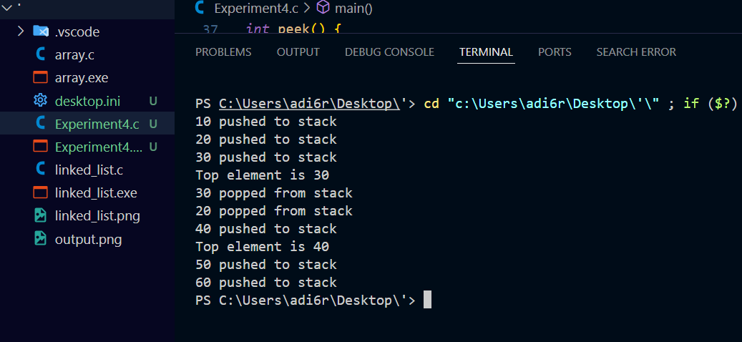

**Lab Assignment 2: Stack Implementation Using Linked Lists**

**#include <stdio.h>**

**#include <stdlib.h>**

**// Node structure**

***struct* Node**

**{**

***int* data;**

***struct* Node* next;**

**};**

**// Stack structure**

***struct* Stack**

**{**

***struct* Node* top;**

**};**

**// Function to create a new node**

***struct* Node* newNode(*int* *data*)**

**{**

***struct* Node* node = (*struct* Node*)malloc(sizeof(*struct* Node));**

**node->data = *data*;**

**node->next = NULL;**

**return node;**

**}**

**// Function to check if the stack is empty**

***int* isEmpty(*struct* Stack* *stack*)**

**{**

**return *stack*->top == NULL;**

**}**

**// Function to push an item onto the stack**

***void* push(*struct* Stack* *stack*, *int* *data*)**

**{**

***struct* Node* node = newNode(*data*);**

**node->next = *stack*->top;**

***stack*->top = node;**

**printf("%d pushed to stack\n", *data*);**

**}**

**// Function to pop an item from the stack**

***int* pop(*struct* Stack* *stack*)**

**{**

**if (isEmpty(*stack*)) {**

**printf("Stack Underflow\n");**

**return -1;**

**}**

***struct* Node* temp = *stack*->top;**

***int* popped = temp->data;**

***stack*->top = temp->next;**

**free(temp);**

**return popped;**

**}**

**// Function to peek the top element of the stack**

***int* peek(*struct* Stack* *stack*)**

**{**

**if (isEmpty(*stack*))**

**{**

**printf("Stack is Empty\n");**

**return -1;**

**}**

**return *stack*->top->data;**

**}**

***int* main()**

**{**

***struct* Stack* stack = (*struct* Stack*)malloc(sizeof(*struct* Stack));**

**stack->top = NULL;**

**push(stack, 10);**

**push(stack, 20);**

**push(stack, 30);**

**printf("Top element is %d\n", peek(stack));**

**printf("%d popped from stack\n", pop(stack));**

**printf("%d popped from stack\n", pop(stack));**

**push(stack, 40);**

**printf("Top element is %d\n", peek(stack));**

**return 0;**

**}**

